**DATA STRUCTURE LAB**

**PROJECT**

**(15B17CI371)**

**PUBLIC CALL OPERATIONS**

Submitted by:

**PRIYANSH SHARMA (9919103001)**

**KOUSTUBH SINHA (9919103008)**

**PRANJAL TIWARI (9919103010)**

**VAIBHAV KANSAL (9919103020)**

Submitted To:

**Dr. RAJU PAL**



* **For Inserting Names:**

void solve(){

int n;

cin>>n;

unordered_set<string>s;

for(int i=0;i<n;i++){

string s1;

cin>>s1;

s.insert(s1);

}

for(auto x:s)

cout<<x<<endl;

cout<<s.size()<<endl;

return ;

}

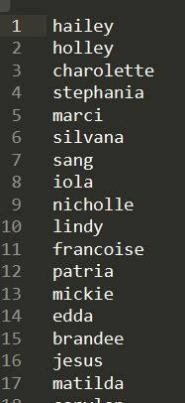

* **For Inserting Phone numbers:**

void solve(){

unordered_set<string>s;

unordered_set<string>s1;

for(int i=0;i<450;i++){

string temp="9";

for(int j=0;j<7;j++){

temp+=(rand()%10+'0');

}

s1.insert(temp);

}

// cout<<s1.size()<<endl;

// for(auto x:s1)

// cout<<x<<endl;

unordered_set<string>s2;

for(int i=0;i<350;i++){

string temp="8";

for(int j=0;j<7;j++){

temp+=(rand()%10+'0');

}

s2.insert(temp);

}

unordered_set<string>s3;

for(int i=0;i<150;i++){

string temp="7";

for(int j=0;j<7;j++){

temp+=(rand()%10+'0');

}

s3.insert(temp);

}

unordered_set<string>s4;

for(int i=0;i<150;i++){

string temp="6";

for(int j=0;j<7;j++){

temp+=(rand()%10+'0');

}

s4.insert(temp);

}

for(auto x:s1)

s.insert(x);

for(auto x:s2)

s.insert(x);

for(auto x:s3)

s.insert(x);

for(auto x:s4)

s.insert(x);

cout<<s.size()<<endl;

for(auto x:s)

cout<<x<<endl;

return ;

}

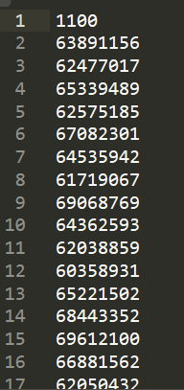

* **For Inserting States:**

void solve(){

vector<string>A={"Maharashtra","Uttar_Pradesh",

"Bihar","Madhya_Pradesh","Delhi",

"Kerela","Tamil_Nadu","Gujarat",

"Rajasthan","Assam",”Punjab”};

vector<string>states;

for(int i=0;i<1000;i++){

int x=rand()%11;

states.pb(A[x]);

}

// cout<<states.size()<<endl;

for(auto x:states)

cout<<x<<endl;

return ;

}

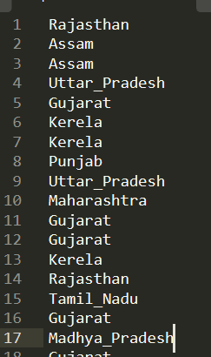

* **For Inserting Operators:**

void solve(){

vector<string>A={"Jio","Airtel","Vodafone","Idea","BSNL"};

vector<string>operators;

for(int i=0;i<1000;i++){

int x=rand()%5;

operators.pb(A[x]);

}

// cout<<operators.size()<<endl;

for(auto x:operators)

cout<<x<<endl;

return ;

}

